Banking System

Table contents

1. Problem Statement
2. Functional Specifications
3. Technical Description

# Problem Statement

Banking System is a simple console application without graphics. It is similar to the one we use in real time by visiting banks where, any customer can make truncations and can owe multiple accounts with the same bank.

# Functional Specifications

* + All records are saved in a file.
  + Key features of the system are:

1. Login as admin: there exists only one admin for the system
2. Register as new customer: Any new customer should be allowed to register for opening an account
3. Login as customer: existing customer can login and perform transaction, update details for any of his/her multiple accounts

# Look at following screenshot:

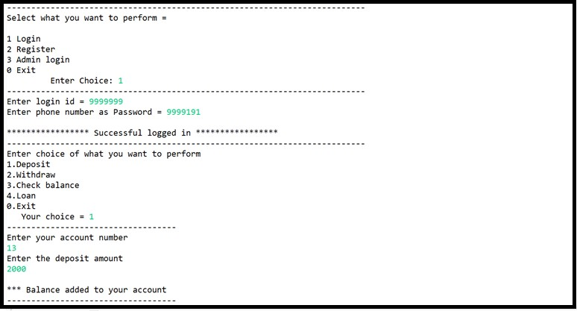

1. **Technical Specifications:**
   * Use data-structures for storing data before adding it to file (i.e. Linked list)
   * Data Validation should be implemented where length of the phone no. should be 10 , email id must contain @
   * If you store date then check if the date is valid or not before storing in the file.
   * Write optimised logic for searching as time complexity should not get increased while searching any information.
   * For this you can store all data in sorted order of account_number or customer number.
   * Write Menu driven program for
2. Admin:
3. View customers
4. Update customer
5. Search :
   1. Search by account number
   2. Search by name
6. Delete customer
7. exit
8. Customer:
   1. View all accounts
   2. Open new account with exiting customer id
   3. Update details
   4. Deposit
   5. Withdraw
   6. Check balance
   7. Exit
9. Register as customer:

Allow new customer entry where customer id should be auto-generated

b) Delete a specific field only i.e. email,other number,etc